**WEEK – 01:**

**Overview of C, Constants, Variables and**

**Data Types**

**WEEK:01-01**

**ROLL NO:240801161**

**NAME: KEERTHANA S**

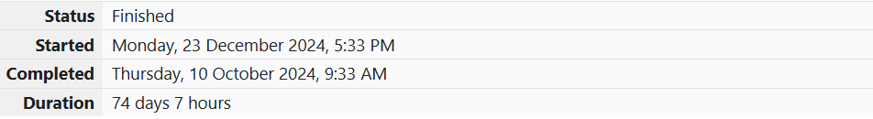

**QUESTION: 1**

**SAY “HELLO WORLD!” WITH C**

**Problem Statement:**

This is a simple challenge to help you practice printing to stdout.

We're starting out by printing the most famous computing phrase of all time! In the editor

below, use either printf or cout stdout.

to print the string Hello, World! to stdout.

**Input Format**

You do not need to read any input in this challenge**.**

**Output Format**

Print Hello, World! to stdout.

**Sample Output 1**

**Hello, World!**

**PROGRAM:**

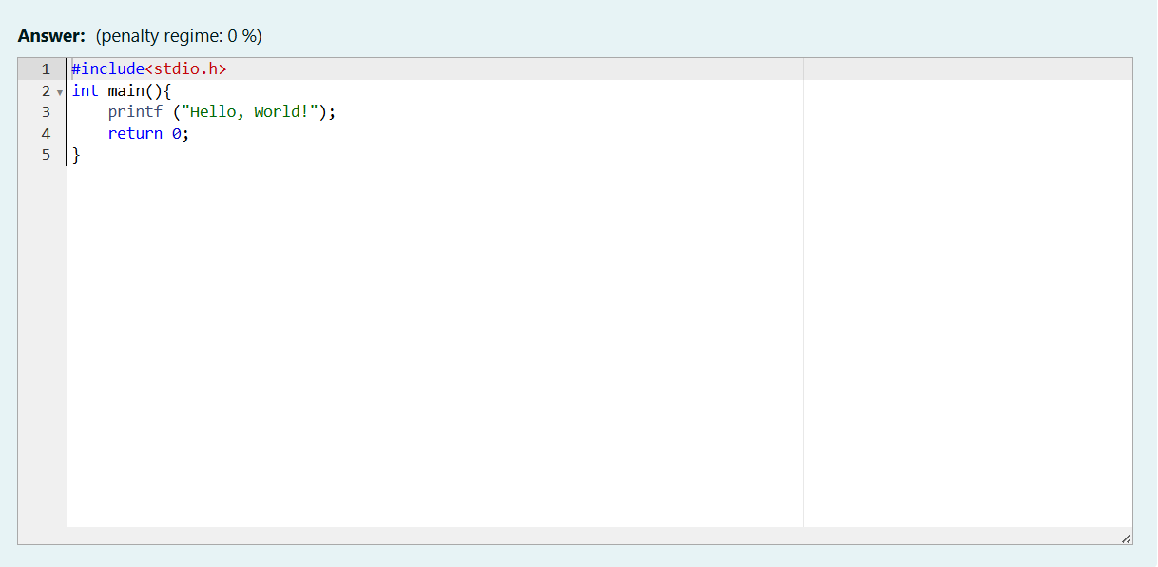

**OUTPUT:**

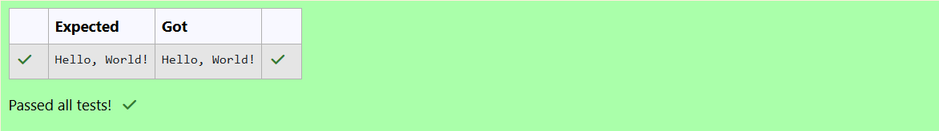

**QUESTION: 2**

**PLAYING WITH CHARACTERS**

**Problem Statement:**

This challenge will help you to learn how to take a character, a string and a sentence as

input in C. To take a single character ch as input, you can use scanf("%c", &ch); and

printf("%c", ch) writes a character specified by the argument char to stdout:

char ch;

scanf("%c", &ch);

printf("%c", ch);

This piece of code prints the character ch. You can take a string as input in C using

scanf(“%s”, s). But it accepts string only until it finds the first space.

In order to take a line as input, you can use scanf("%[^\n] %*c", s); where s is defined as

chars [MAX_LEN] where MAX_LEN is the maximum size of s. Here, [] is the scanset

character. ^\n stands for taking input until a newline isn't encountered. Then, with this

%*c, it reads the newline character and here, the used * indicates that this newline

character is discarded.

Note: After inputting the character and the string, inputting the sentence by the above

mentioned statement won't work. This is because, at the end of each line, a new line

character(\n) is present. So, the statement: scanf("%[^\n] %*c", s); will not work because

the last statement will read a newline character from the previous line. This can be

handled in a variety of ways and one of them being: scanf("\n"); before the last statement.

Task: You have to print the character, ch, in the first line. Then print s in next line. In the

last line print the sentence, sen.

**Input Format**

First, take a character, ch as input. Then take the string, s as input. Lastly, take the

sentence sen as input

**Output Format**

Print three lines of output. The first line prints the character, ch. The second line prints

the string, s. The third line prints the sentence, sen.

**Sample Input 1**

C

program

Programming using C

**Sample Output 1**

C

program

Programming using C

**PROGRAM:**

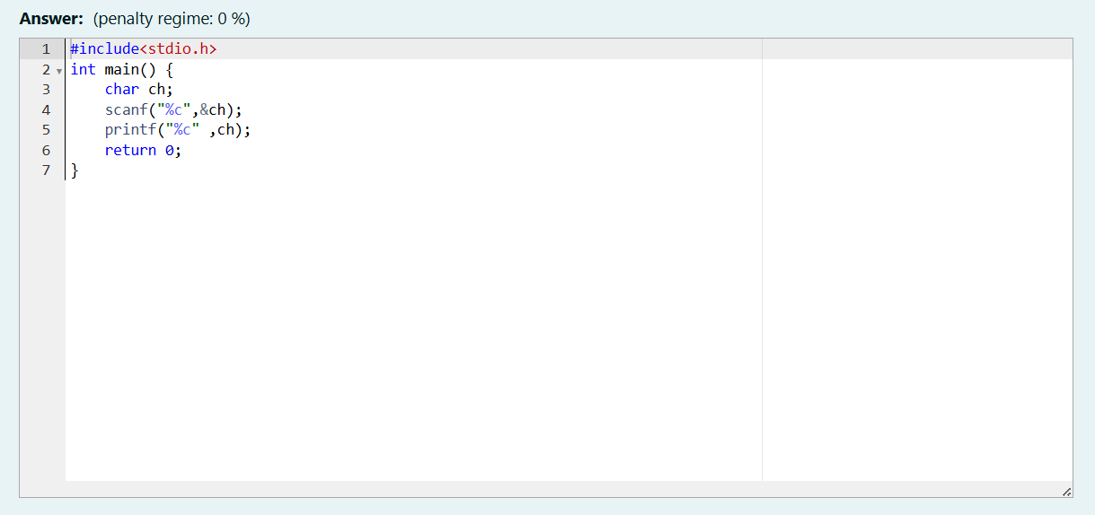

**OUTPUT:**

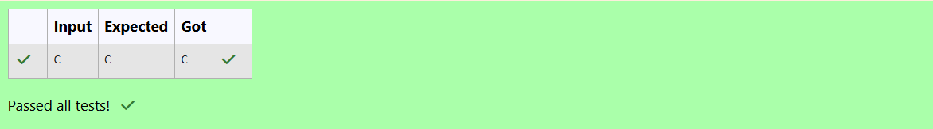

**QUESTION: 3**

**SUM AND DIFFERENCES OF TWO NUMBERS**

**Problem Statement:**

The fundamental data types in c are int, float and char. Today, we're discussing int an

float data types.

The printf() function prints the given statement to the console. The syntax is printf("formatstring",argument_list);. In the function, if we are using an integer, character, string or float

as argument, then in the format string we have to write %d (integer), %c (character), %s(string), %f (float) respectively.

The scanf() function reads the input data from the console. The syntax is scanf("formatstring",argument_list);. For ex: The scanf("%d",&number) statement reads integer

number from the console and stores the given value in variable number.

To input two integers separated by a space on a single line, the command is scanf("%d%d", &n, &m), where n and m are the two integers.

Task

Your task is to take two numbers of int data type, two numbers of float data type as input

and output their sum:

1. Declare 4 variables: two of type int and two of type float.

2. Read 2 lines of input from stdin (according to the sequence given in the 'Input Format'

section below) and initialize your 4 variables.

3. Use the + and - operator to perform the following operations:

• Print the sum and difference of two int variable on a new line.

• Print the sum and difference of two float variable rounded to one decimal place on

a new line.

**Input Format**

The first line contains two integers. The second line contains two floating point numbers.

Constraints: 1 ≤ integer variables ≤ 104, 1 ≤ float variables ≤ 104

**Output Format**

Print the sum and difference of both integers separated by a space on the first line, and

the sum and difference of both float (scaled to 1 decimal place) separated by a space on

the second line.

**Sample Input**

10 4

4.0 2.0

**Sample Output**

14 6

6.0 2.0

**PROGRAM:**

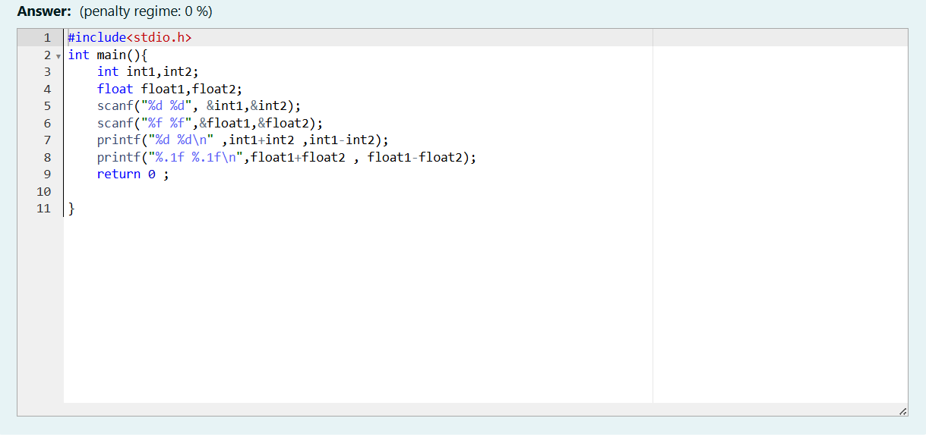

**OUTPUT:**

